

**lab report 2**

Andrew Nady

900184042

Question 2:

Technical summary:

Steps:

* In the zero experiment,
  + we copied the files of the UART to Vivado.
  + Then downloaded tera term.
  + And then we tested the UART using the tera term by clicking the assigned keys” a, …”.
* In the first experiment,
  + we added the full adder module
  + then a ripple carry module to call 4 full adders to make 4-bit full adder.
  + We added the seven-segment display of the previous lab and it constrain file.
  + Then we make a top module to connect the UART, ripple carry and the seven-segment display.
* In the second experiment,
  + we have 8 bits output from the UART, so we make the number in the BCD and the seven-segment display module 8 bits.
  + Second, we make a variable called comp which is 2’s Complement =~num+1.
  + Then we made a condition if the most significant bit is 1 then pass the comp to the BCD. Otherwise, pass the num as normal.
  + In order to display the negative sign, we make instead of the thousand, an if statement that sees if the most significant bit is 1, then assign anode to 4’n0111 to activate the first digit, otherwise we gave it 4 1’s. then we gave the LED_BCD a value 10. Then we added a case below which implements the ‘- ‘, when the lED_BCD is activated and equals to 10.
* In the third experiment,
  + We take UART the same as the other experiments
  + We take seven-segment display and only modified the bits of the input num and made it 4 bits.
  + We take the BCD and only modified the bits of the input num and made it 4 bits
  + Then made a top module to connect everything together.

Components:

1. Nexys 100T a7
2. Vivado
3. Tera term

Schematic design:

Experiment 1:

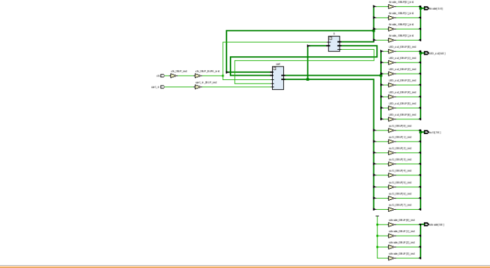

Experiment 3:

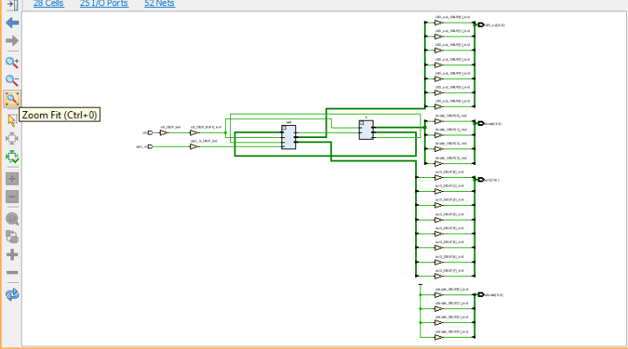

Code functionalities:

* In the zero experiment, when clicking on specific keys on keyboard it makes specific led on.
* In the first experiment, adding two 4 bits with each other and then display the result in the seven-segment display
* In the second experiment, displaying any number on the seven-segment display whether it was negative or positive. If it is negative the first digit from the left will display the sign ‘-’
* In the third experiment, adding any two numbers of four bits whether they are negative or positive. (eg -6+2=-4). In this example, it will display – 006 on the seven segment display

Question 3:

Results:

Experiment 0:

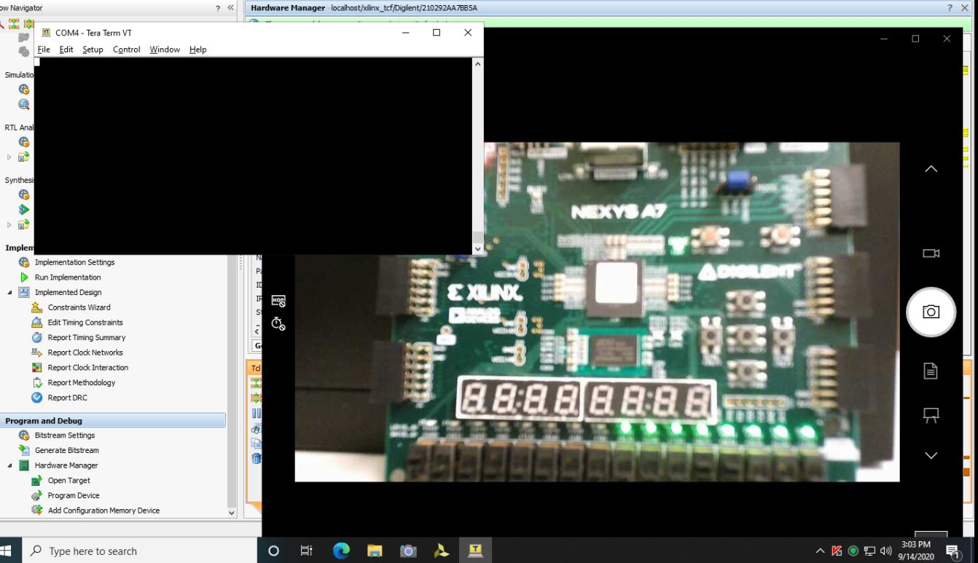

Experiment 1:

12+0 =12

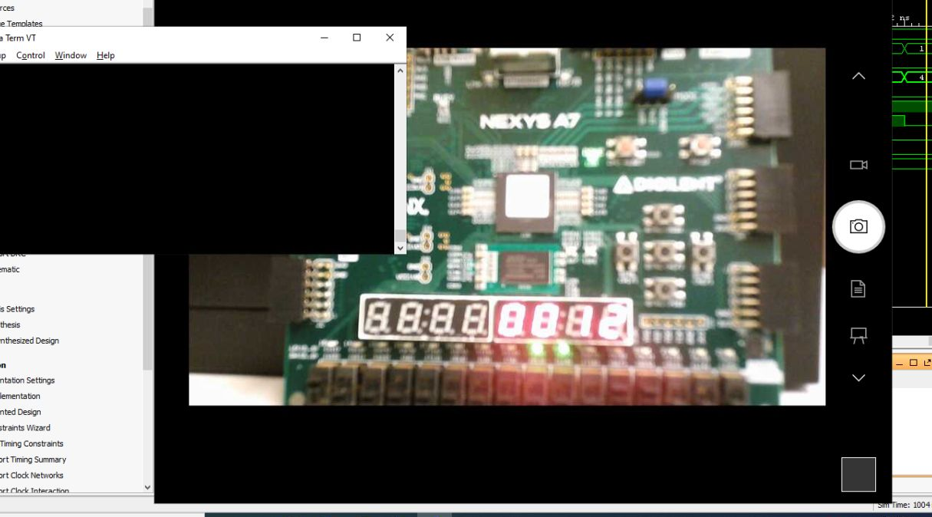

Experiment 2:

Displaying ‘-1’

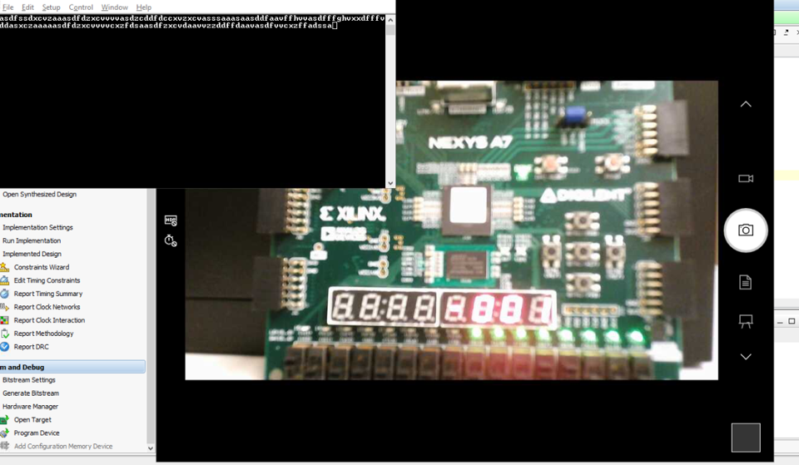

Experiment 3:

1010 + 0010 = -6 + 2 =-4

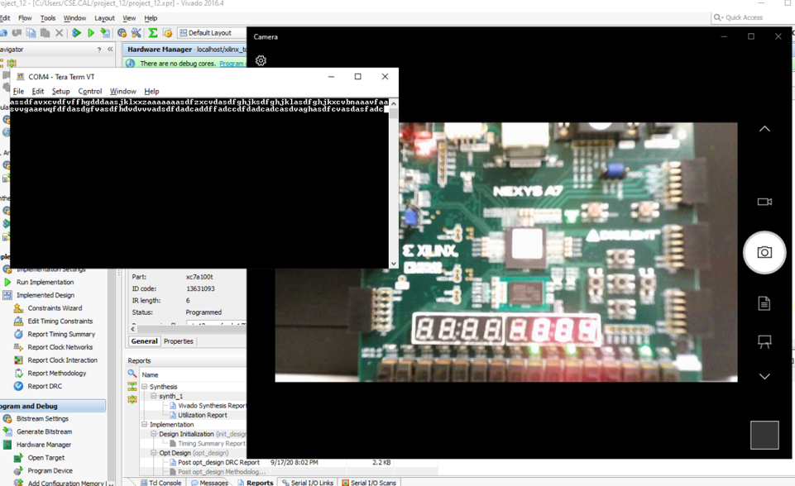

**Problem (4)  
Comparison:**

Utilization:

|  |  |  |
| --- | --- | --- |
|  | **Experiment 1** | **Experiment 3** |
| **SCREENSHOTS** |  |  |

Delay:

|  |  |  |
| --- | --- | --- |
|  | **Experiment 1** | **Experiment 3** |
| **SCREENSHOTS** |  |  |

* Utilization is less than in experiment 3, because we decreased the input num from 13 bit to 4 bits only which decrease the hardware a little bit (I think so).

**Problem (5)**

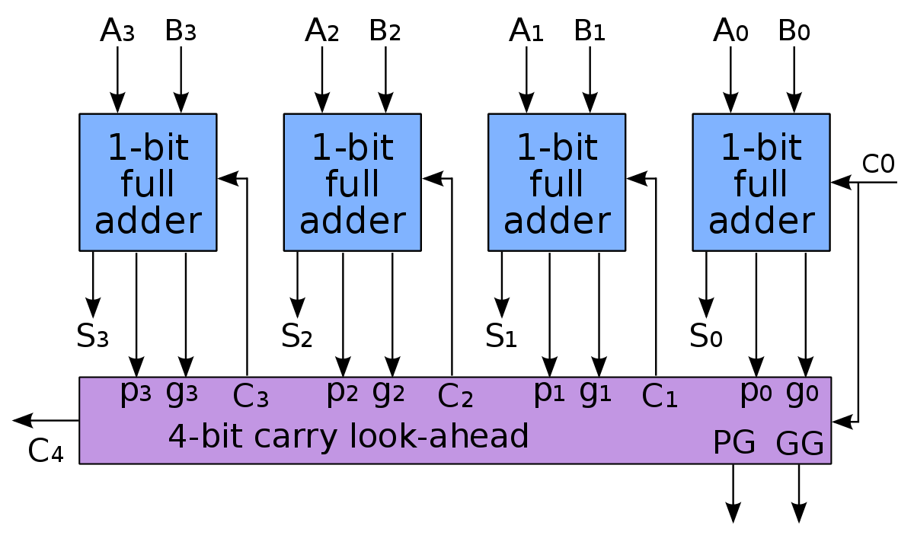

what should be done is replacing the full adder with the lock ahead adder.

4-bit carry lookahead adder

|  |
| --- |
| // file: CLA.v  // author: @andrewhany  **`timescale** **1**ns / **1**ps  **module** **CLA**( **input** [**3**:**0**] x , **input** [**3**:**0**] y , **output** [**4**:**0**] res );  **wire** [**4**:**0**] **C**;  **wire** [**3**:**0**] **G**,**P**,sum;  FullAdder adder1 (x[**0**],y[**0**],**C**[**0**],sum[**0**]);  FullAdder adder2 (x[**1**],y[**1**],**C**[**1**],sum[**1**]);  FullAdder adder3 (x[**2**],y[**2**],**C**[**2**],sum[**2**]);  FullAdder adder4 (x[**3**],y[**3**],**C**[**3**],sum[**3**]);    **assign** **G**[**0**]= x[**0**] & y[**0**];  **assign** **G**[**1**]= x[**1**] & y[**1**];  **assign** **G**[**2**]= x[**2**] & y[**2**];  **assign** **G**[**3**]= x[**3**] & y[**3**];  **assign** **P**[**0**]= x[**0**] | y[**0**];  **assign** **P**[**1**]= x[**1**] | y[**1**];  **assign** **P**[**2**]= x[**2**] | y[**2**];  **assign** **P**[**3**]= x[**3**] | y[**3**];  **assign** **C**[**0**]=**1'b0**;  **assign** **C**[**1**]= **G**[**0**] | (**P**[**0**] & **C**[**0**]);  **assign** **C**[**2**]= **G**[**1**] | (**P**[**1**] & **C**[**1**]);  **assign** **C**[**3**]= **G**[**2**] | (**P**[**2**] & **C**[**2**]);  **assign** **C**[**4**]= **G**[**3**] | (**P**[**3**] & **C**[**3**]);  **assign** res ={**C**[**4**],sum};  **endmodule** |

Testbench to test it:

|  |
| --- |
| // file: testbench_tb.v  // author: @andrewhany  // Testbench testbench_tb  **`timescale** **1**ns/**1**ns  **module** testbench_tb;  **reg** [**3**:**0**] x;  **reg** [**3**:**0**] y;  **wire** [**4**:**0**] res;  **CLA** cla ( x , y , res );  **initial**  **begin**  x[**3**:**0**]=**4'b0010**;  y[**3**:**0**]=**4'b0010**;  #**100**  x[**3**:**0**]=**4'b0011**;  y[**3**:**0**]=**4'b0010**;  #**100**  x[**3**:**0**]=**4'b0011**;  y[**3**:**0**]=**4'b0110**;  **end**  **endmodule** |

Simulation:

0x2+0x2 =0x4, 0x2+0x3=0x5, 0x6+0x3=0x9

So, it is working properly



|  |  |
| --- | --- |
| utilization | delay |
|  |  |

There is a folder for Question 5 which contains the whole project.

**Problem (6)**

* Utilization in the CLA increases because the gates used in CLA is more than used in RCA, this can be noticed when seen the above figure which indicates that the gates and the hardware used in CLA is more than that used in RCA
* The delay is almost the same. However it is a bit faster in CLA than RCA